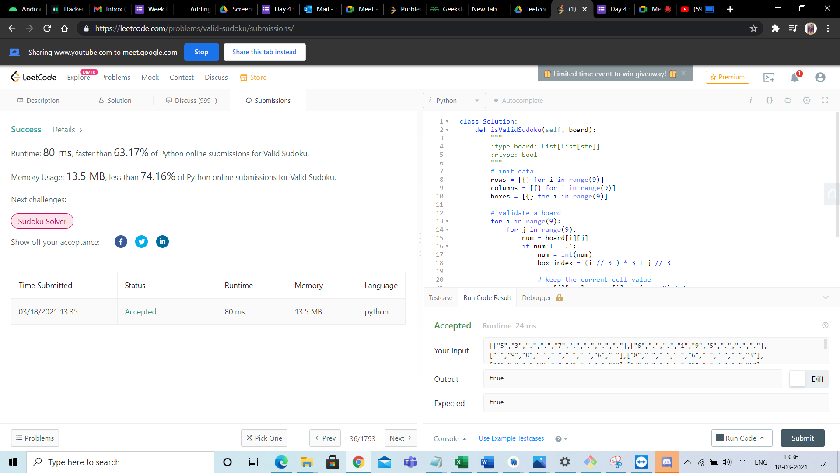
Androi
Hu Hacker
M Inbox
E Week 1 |
Adding
A Screen
Day 4: o Mail -
01 Meet -
Probler 26 Geeksf
New Tab
Aleetco
G (1
E Day 4: o Me
(59
+
C
o
. https://leetcode.com/problems/valid-sudoku/submissions/
Sharing www.youtube.com to meet.google.com
Stop
Share this tab instead
Day 18
CleetCode
Explore
Problems
Mock
Contest
Discuss
Store
i Limited time event to win giveaway! T X
* Premium
Et
too
3 Description
8 Solution
Discuss (999+)
Submissions
i Python
• Autocomplete
Success
Details »
class Solution:
def isValidSudoku(self, board):
Runtime: 80 ms, faster than 63.17% of Python online submissions for Valid Sudoku.
ovo AWN
: type board: List[List[str]] :rtype: bool
Memory Usage: 13.5 MB, less than 74.16% of Python online submissions for Valid Sudoku.
# init data rows = [{} for i in range (9)] columns = [{} for i in range(9)] boxes = [{} for i in range(9)]
Next challenges:
Sudoku Solver
Show off your acceptance:
f
o covoin N
# validate a board for i in range(9): for j in range(9):
num = board[i][j] if num != '.':
num = int(num) box_index = (i // 3 ) * 3+; // 3
20
Time Submitted
Status
Runtime
Runtime
Memory
Language
# keep the current cell value
---.-r: ... --- -1:1 --Il-.. Debugger &
.
1
Testcase
Run Code Result
03/18/2021 13:35
Accepted
80 ms
13.5 MB
python
Accepted
Runtime: 24 ms
Your input
roc" 7"
c FI
C IL S . . . . . . 6 . ) 1 9
. . . FOR HECHICHI 98 . . . . 6 T , 8). .
6
.31,
Output
true
Diff
Expected
true
: Problems
X Pick One
< Prev
36/1793
Next >
Console.
Use Example Testcases
Run Code
Submit
13:36
1
Type here to search
o
v
^
"
EN
18-03-2021
L

